Ideation Phase

Define the Problem Statements

|  |  |
| --- | --- |
| Date | 29 July 2025 |
| Team ID | LTVIP2025TMID52293 |
| Project Name | docspot: seamless appointment booking for  health |
| Maximum Marks | 2 Marks |

**Customer Problem Statement Template:**

Create a problem statement to understand your customer's point of view. The Customer Problem Statement template helps you focus on what matters to create experiences people will love.

A well-articulated customer problem statement allows you and your team to find the ideal solution for the challenges your customers face. Throughout the process, you’ll also be able to empathize with your customers, which helps you better understand how they perceive your product or service.

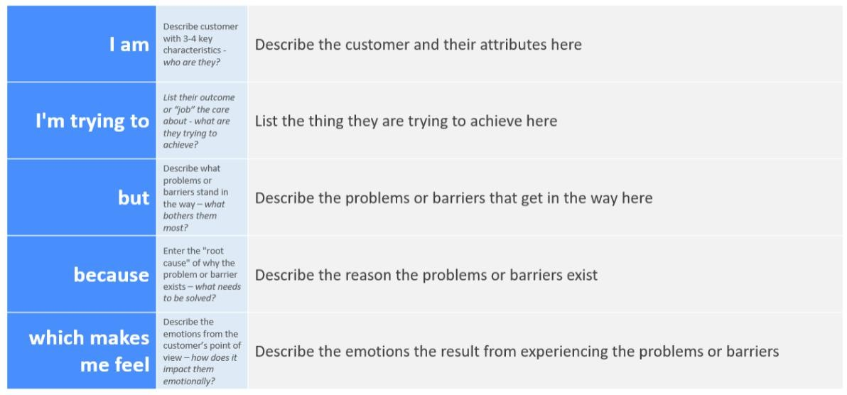

Reference: <https://miro.com/templates/customer-problem-statement/>

**Example:**

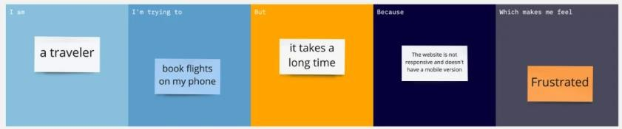

|  |  |  |  |  |  |
| --- | --- | --- | --- | --- | --- |
| **Problem**  **Statement (PS)** | **I am**  **(Customer)** | **I’m trying to** | **But** | **Because** | **Which makes me feel** |
| PS-1 | A working  professional | Book a  doctor’s | Available  slots are | Most  hospital/clini | Stressed and  discouraged |

|  |  |  |  |  |  |
| --- | --- | --- | --- | --- | --- |
|  | with a busy schedule | appointment quickly | hard to find and the process is time- consumin  g | c websites are not user- friendly or don’t show real-time availability |  |
| PS-2 | A parent of a sick child | Find a nearby pediatrician urgently | I have to call multiple clinics or visit physically | There is no centralized platform showing doctors by location, availability, and specializatio  n | Worried and helpless |